**LAB MENU**

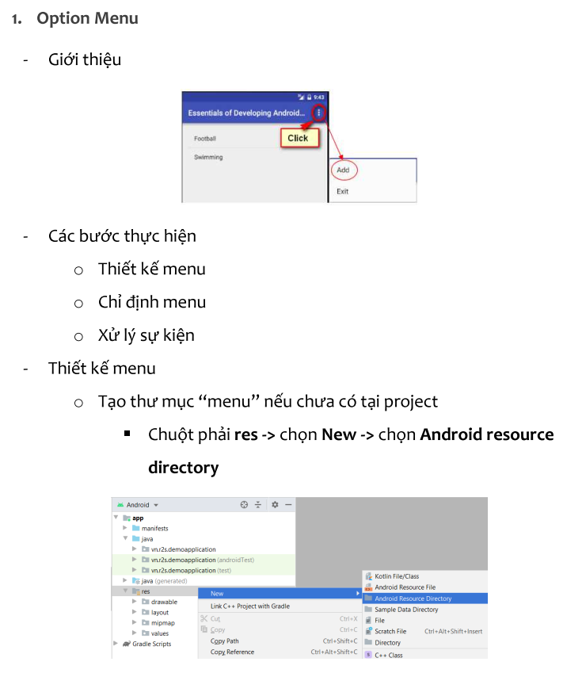

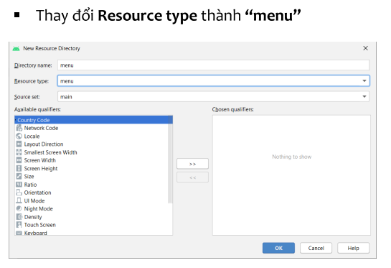

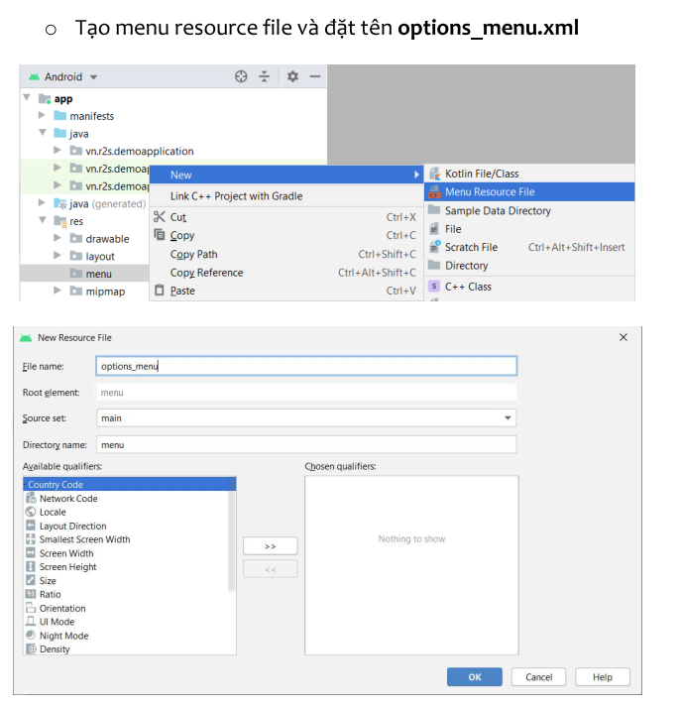

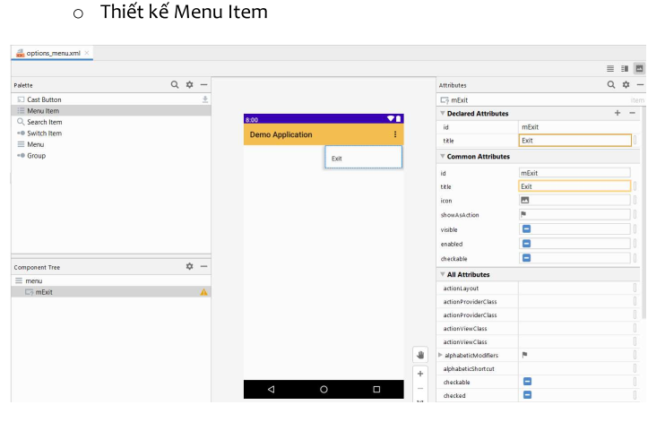

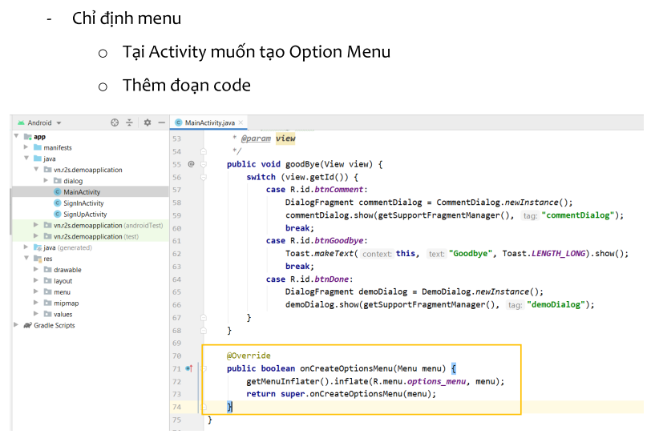

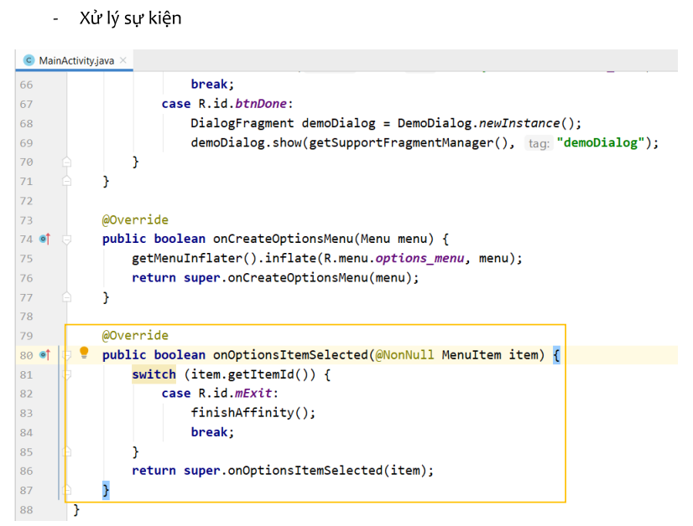

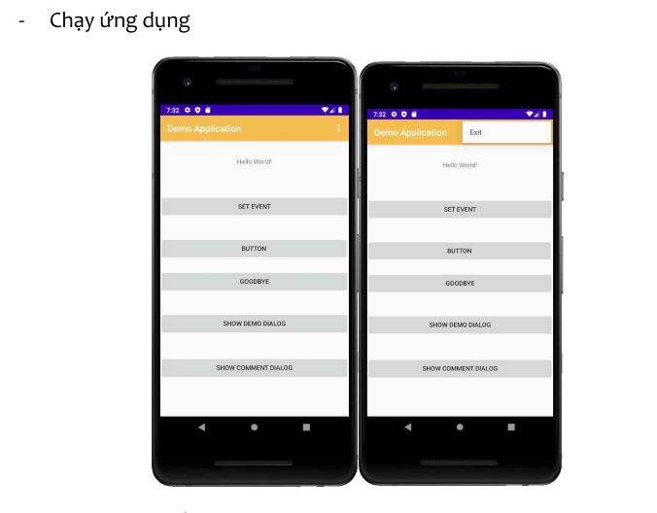

**2. Popup menu**

Tạo Project mới với tên popup_menu

Tạo thư mục menu, menu resource: menu_popup

Code menu_popup.xml

Tạo giao diện ActivityMain.xlm

Code MainActivity:

Run project: Click **popup menu**

Cập nhật lại MainActivity.java

Run app có kết quả như sau:

3. **Context menu**

Tạo Project và menu_context

Tạo giao diện cho context_menu.xml

Tạo giao diện cho Activity_Main.xml

Tại MainActivity.java nhập code:

Run chương trình, long_click buton “CHỌN MÀU”

Thiết lập icon cho context menu (nếu cần)

**Set Color cho các màn hình khi chọn**

